

M.Sc. Computer Science and Engineering

Hypermedia Applications Project

Leoni Luca 10574709

Minotti Luca 10572239

Ratti Francesco 10640265

www.ourcompany.com

Design Report

23rd March 2021

Version 1.0

**Abstract**

*Plug-IT* is a medium-sized Italian company operating in the ICT sector that needs a website to show the information related to its services. The goal of this document is to provide a functional and visual description of the website to be implemented. In particular, it aims at describing the main design choices through models, schemas and use case scenarios. Furthermore, it will also present the structure of the database from both a conceptual and logical viewpoint.

**Authors**

**Francesco Ratti**

*MSc Computer Science and Engineering*

[francesco2.ratti@mail.polimi.it](mailto:francesco2.ratti@mail.polimi.it)

+39 3342546426



**Luca Minotti**

*MSc Computer Science and Engineering*

[luca2.minotti@mail.polimi.it](mailto:luca2.minotti@mail.polimi.it)

+39 3315228707



**Luca Leoni**

*MSc Computer Science and Engineering – EIT Digital Human Computer Interaction and Design*

[luca3.leoni@mail.polimi.it](mailto:luca3.leoni@mail.polimi.it)

+39 3484124137



Contents

Introduction 5

Requirements 5

Purpose 5

1. Conceptual Design 6

1.1. Content Design 6

**1.1.1.** **C-IDM Diagram** 6

**1.1.2.** **Content Tables** 7

1.2. Navigation Design 8

**1.2.1.** **Content tables - pages mapping** 8

**1.2.2.** **P-IDM Diagram** 10

2. Visual Design 11

2.1. Home Page 11

2.2. Topics 11

2.3. Kind of Topic 11

2.4. Introductory Pages 11

3. Interaction Scenarios 12

4. Database Design 13

4.1. Entity-Relationship Diagram 13

4.2. Relational Tables 13

**Introduction**

**Requirements**

*Plug-IT* is a medium-sized Italian company operating in the ICT sector that needs a website to make itself known and to show its offers. The system must show all the information relating to the *areas* (more than 3) in which it operates and the related *services* (more than 30) it offers.

In addition to the *general description* of the company and its contacts, all information about the *people* (more than 20) working at *Plug-IT* must be shown in detail.

In particular, some relationship must be evident on the website:

* People are related to areas (and vice versa) in different ways, e.g., because they are responsible for an area or because they work in an area
* People are related to services (and vice versa) in different ways, e.g., because they are project manager or because they are reference for assistance for a service
* Services are related to the areas they belong to (and vice versa)

**Purpose**

The goal of this document is to provide a functional and visual description of the website to be implemented. In particular, it aims at describing the main design choices through models, schemas and use case scenarios. Moreover, it will also present the structure of the database from both a conceptual and logical viewpoint.

1. **Conceptual Design**

The conceptual design of the website is detailed in this chapter. In particular, the choices relating to the contents, their mapping into pages and the navigation between them will be explained in detail in the following.

* 1. **Content Design**

This section describes the *C-IDM (Content Interaction Dialogue Model)*, which is a model that represents the website in terms of a dialogue between the human and the application. In particular, it explains what the dialogue is about and how the subjects of conversation are classified, mutually related and grouped. It also provides information on what can be said about each of these categories.

* + 1. **C-IDM Diagram**

The core of the model consists of the three main kind of topic *Services*, *People* and *Areas* that are interrelated. The kind of topic *Areas* consists of all the fields in which the company operates. For each of them, there is a manager and many other employees. Every *Area* is also associated with one or more services. Each *Service* employs a project manager and has multiple references for assistance. Furthermore, the diagram highlights the association between the people and the areas in which they operate. Another kind of topic concerns the *Events* organized monthly by the company: they regard a specific field and generally involve one or more employees. Finally, the schema contains other two single topics: the first concerns a general description of *Plug-IT* while the other one deals with how to reach or contact the company.

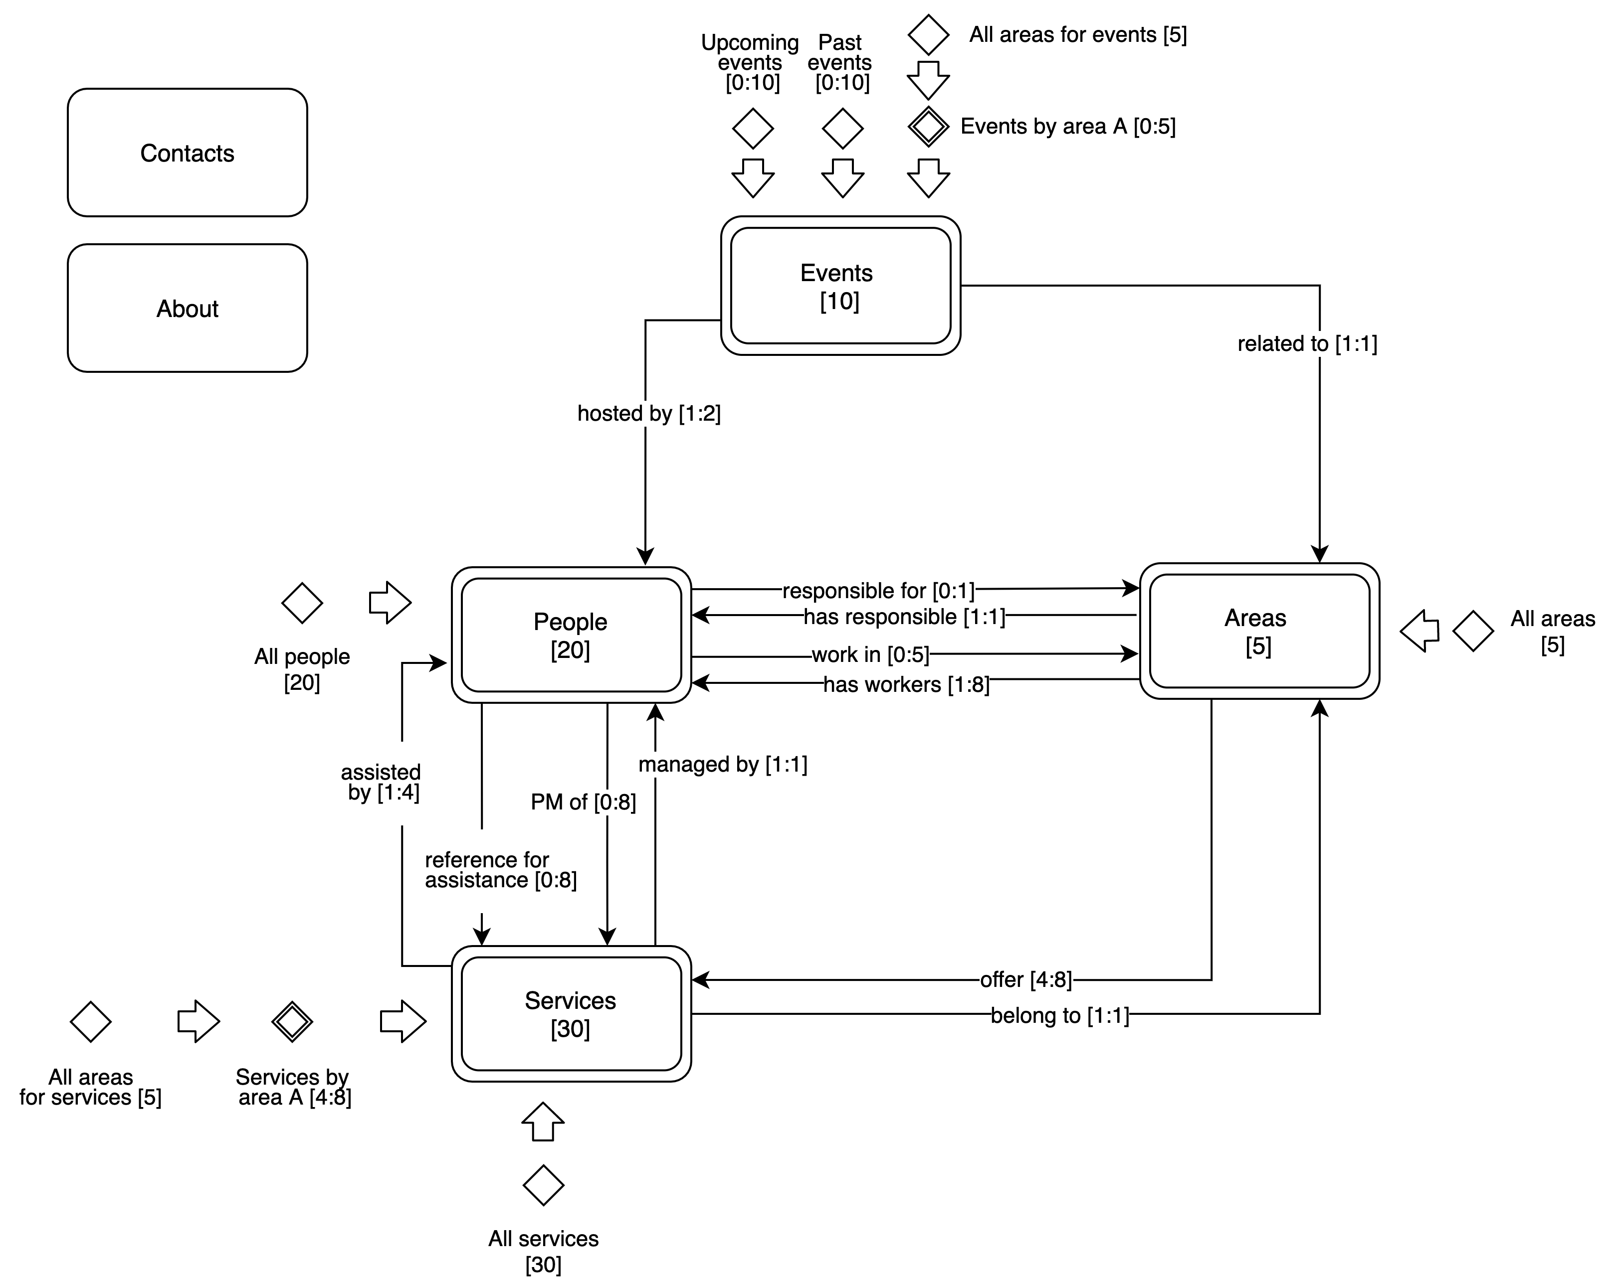

*C-IDM in-the-large diagram*

* + 1. **Content Tables**

In the following tables are defined the contents of the conversation between the human and the application for each category of subject.

|  |
| --- |
| **KIND OF TOPIC:** *People* |
| Employee name: text |
| Position name: text |
| Employee photo: image |
| Employee bio: text (max. 150 words) |
| List of managed areas [area name] |
| List of tasks [service name, area name, task role] |

|  |
| --- |
| **KIND OF TOPIC:** *Areas* |
| Area name: text |
| Area overview: text (max. 250 words) |
| Area responsible (employee name) |
| Area team: list of people [employee photo, employee name, position] |
| List of area services [service name] |

|  |
| --- |
| **KIND OF TOPIC:** *Services* |
| Service name: text |
| Service area: text |
| Service description: text (max. 300 words) |
| Project manager (employee name) |
| Reference assistants: list of people [employee name, task role] |

|  |
| --- |
| **KIND OF TOPIC:** *Events* |
| Event title: text |
| Event area: text |
| Event description: text (max 200 words) |
| Event hosts: list of people (employee name, position) |
| Event details (date, time, location, map) |

|  |
| --- |
| **TOPIC:** *About* |
| Company overview: text (max. 500 words) |

|  |
| --- |
| **TOPIC:** *Contacts* |
| Office information (address, phone, email, map) |

* 1. **Navigation Design**

This chapter describes the mapping between the content identified in the previous sections and the pages that will be implemented. Furthermore, it includes the *N-IDM (Navigation Interaction Dialogue Model)* diagram, which visually represents the choices made during the design of the high-level navigation topology.

* + 1. **Content tables - pages mapping**

The following tables detail the mapping of the previously identified contents into pages.

* **KIND OF TOPIC: *People***

|  |
| --- |
| **INTRODUCTORY PAGE:** *People Page* |
| People introduction: text (max. 150 words) |
| Grid of people [employee name, position, employee photo] |

|  |
| --- |
| **TOPIC PAGE:** *Person Page* |
| Employee name: text |
| Position name: text |
| Employee photo: image |
| Employee bio: text (max. 150 words) |
| List of responsibilities [area name] |
| List of tasks [service name, service area, task role] |

* **KIND OF TOPIC: *Areas***

//Introductory page not needed. The different Area pages will be reached directly from the header.

|  |
| --- |
| **TOPIC PAGE:** *Area Page* |
| Area name: text |
| Area overview: text (max. 250 words) |
| List of services [service name] |

|  |
| --- |
| **TRANSITION PAGE:** *Area Team Page* |
| Area name: text |
| Area responsible (employee name) |
| Area team: list of people [employee name, position] |

* **KIND OF TOPIC: *Services***

|  |
| --- |
| **INTRODUCTORY PAGE:** Our Services *Page* |
| List of services [service name, area, short description (max. 10 words)] |

|  |
| --- |
| **TOPIC PAGE:** *Service Page* |
| Service name: text |
| Service area: text |
| Service description: text (max. 300 words) |

|  |
| --- |
| **TRANSITION PAGE:** *Service Team Page* |
| Service name: text |
| Service area: text |
| Project manager name |
| Reference assistants list [employee name, task role] |

* **KIND OF TOPIC: *Events***

|  |
| --- |
| **INTRODUCTORY PAGE:** Events *Page* |
| List of events [event name, area, date, time, short description (max. 20 words)] |

|  |
| --- |
| **TOPIC PAGE:** *Event Page* |
| Event title: text |
| Event area: text |
| Event description: text (max. 200 words) |
| Event hosts: list of people (employee name, position) |
| Event details (date, time, location, map) |

* **TOPIC: *About***

|  |
| --- |
| **PAGE:** *About Page* |
| Company overview: text (max. 500 words) |

* **TOPIC: Contacts**

|  |
| --- |
| **PAGE:** *Contacts Page* |
| Office information (address, phone, email, map) |

* + 1. **P-IDM Diagram**



P-IDM

1. **Visual Design**
   1. **Home Page**
   2. **Topics**
   3. **Kind of Topic**
   4. **Introductory Pages**
2. **Interaction Scenarios**
3. **Database Design**
   1. **Entity-Relationship Diagram**
   2. **Relational Tables**